#### Experiment 10– Building ASP.net web applications with Database Connectivity

**Objective**

* Learn creating DataBase Connectivity with ASP.Net Web Application

## Create an ASP.net web application

Master pages allow you to create a consistent look and behavior for all the pages (or group of pages) in your web application.

A master page provides a template for other pages, with shared layout and functionality. The master page defines placeholders for the content, which can be overridden by content pages. The output result is a combination of the master page and the content page.

The content pages contain the content you want to display.

When users request the content page, ASP.NET merges the pages to produce output that combines the layout of the master page with the content of the content page.

For more info Visit

<http://asp.net>

<https://www.w3schools.com/asp/default.asp>

<https://docs.microsoft.com/en-us/previous-versions/wtxbf3hh(v=vs.140)?redirectedfrom=MSDN>

The following Exercise will demonstrate how to create and use Master Pages

1. Create a **New Project** in Visual Studio, Selecting **ASP.Net Web Application** and **.Net** **Framework 4.4 in middle Pane** and **Visual C**# Web in left Pane

Name your project **MyWebSite** (follow figure 1)

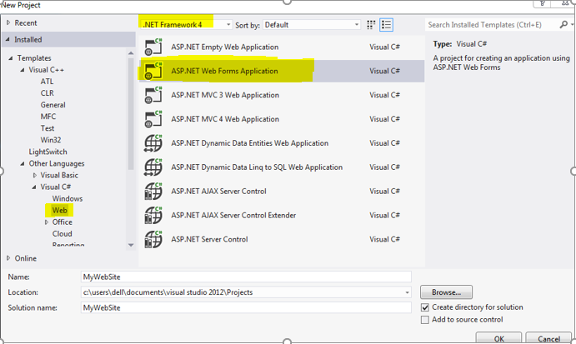

Figure 3

Run your Project here by clicking on the icon of browser

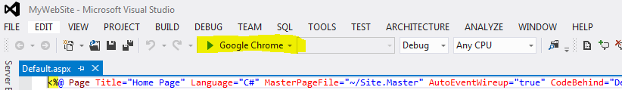

If all goes well a default template will be displayed in the browser.

1. Add Master Page in you Project, using Add New Item Option from Solution Explorer (Follow Figure 2 and 3)

Name this Master Page as **MyMasterPage.Master**

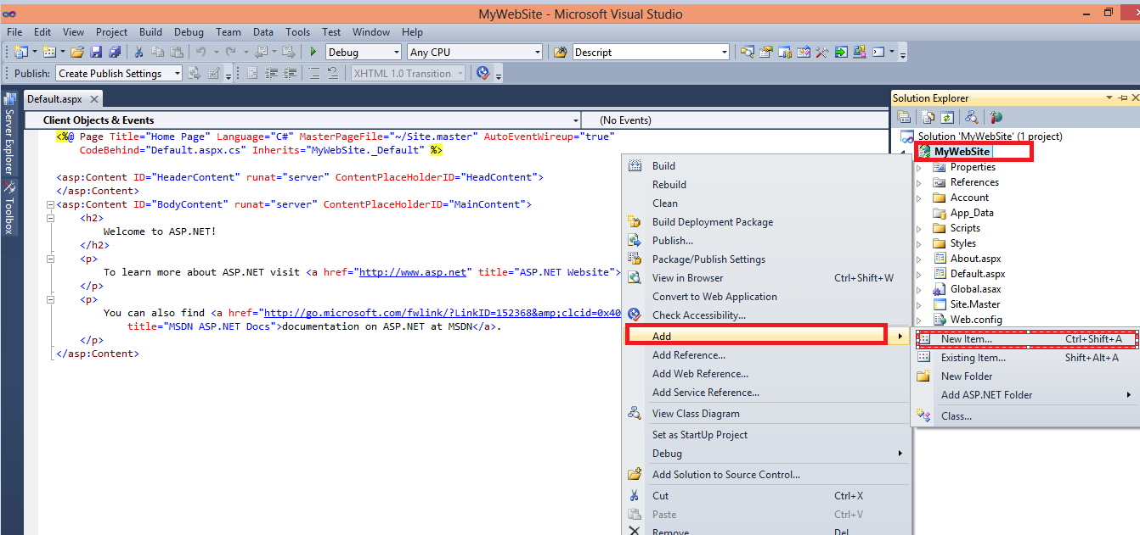

Figure 4

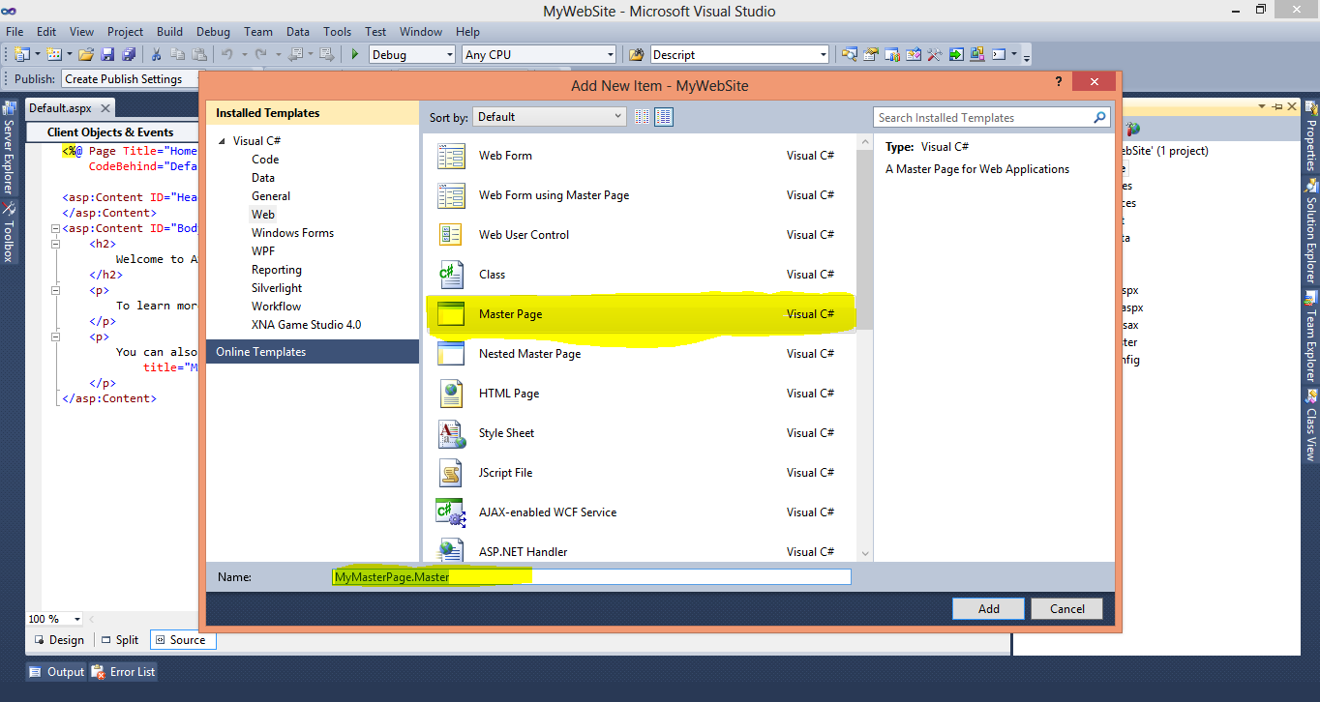

Figure 5

1. Now we will add CSS file and images in our project that will be used in Styling MasterPage

***The Web Template is downloaded from***

<https://all-free-download.com/free-website-templates/>

***You can also download template from this website for your Projects***

***The Template used for This Lab Exercise is***

[*http://all-free-download.com/free-website-templates/snowglass_215.html*](http://all-free-download.com/free-website-templates/snowglass_215.html)

***For Now add from the folder given to you***

Add The CSS files (MyCSSFile.CSS given in **Resource Folder** along with Manual) in your Project using Add Existing Item

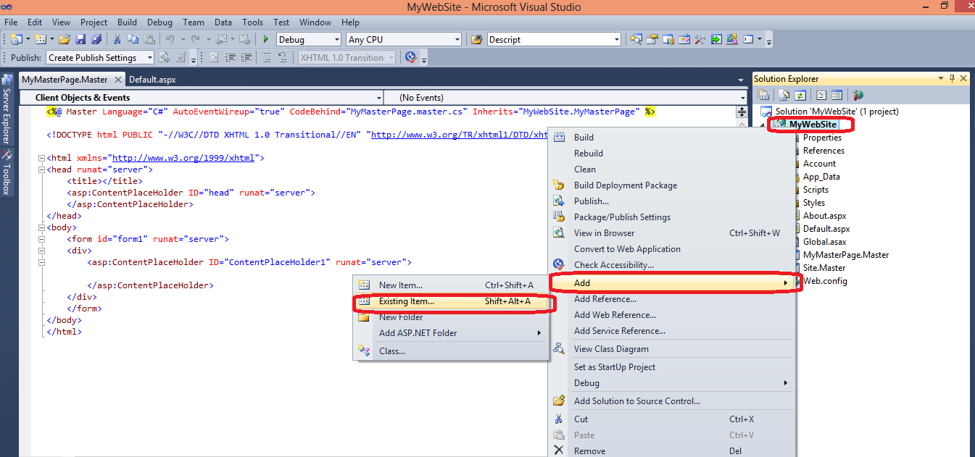

After Adding CSS file create new Folder in your Project named Images using New Folder option (As shown in Figure)

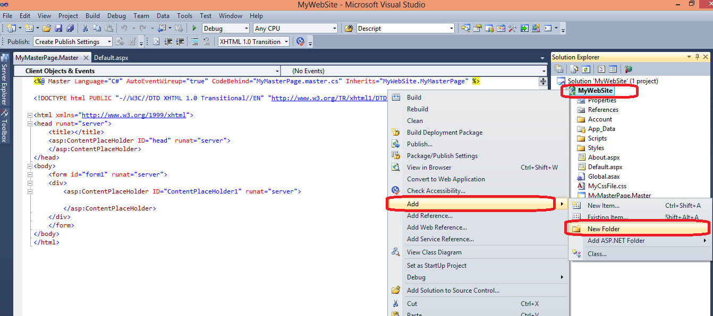

Now add all the images given in **Resources**\Images folder in this Images folder, (as shown in figure)

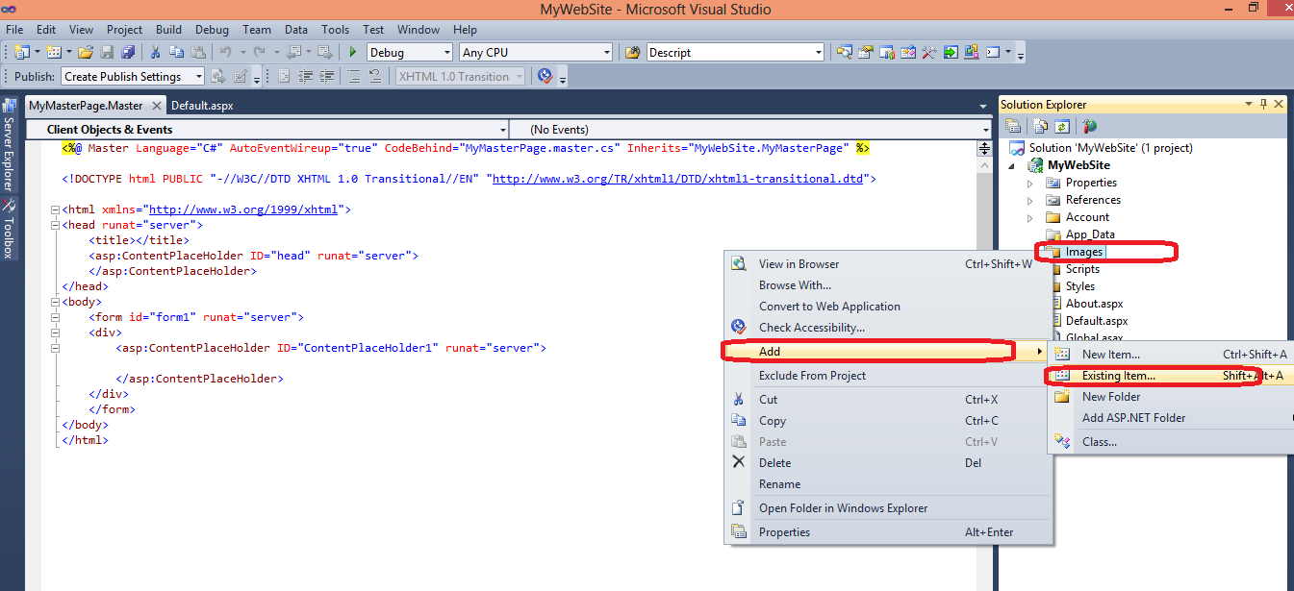

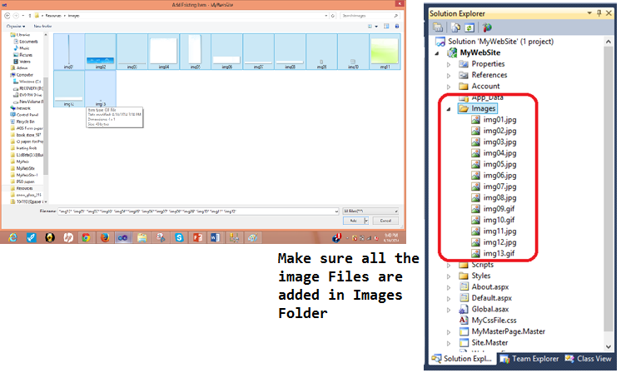

1. Now open MyMasterPage and Drag Drop Css file in Header (as shown in Figure)

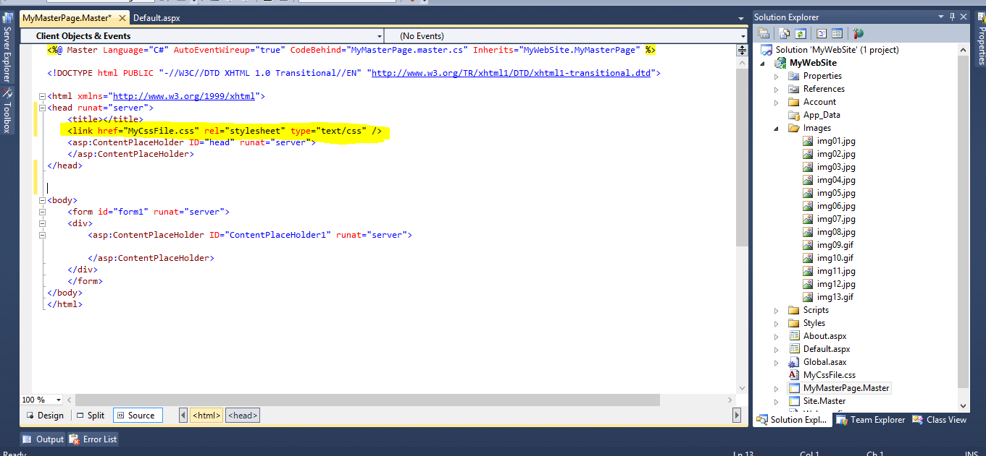

After that Open the MasterPage_Body.txt file given in Resources and Copy All the contents , Replace everything inside the Body tags of MyMasterPage with this content

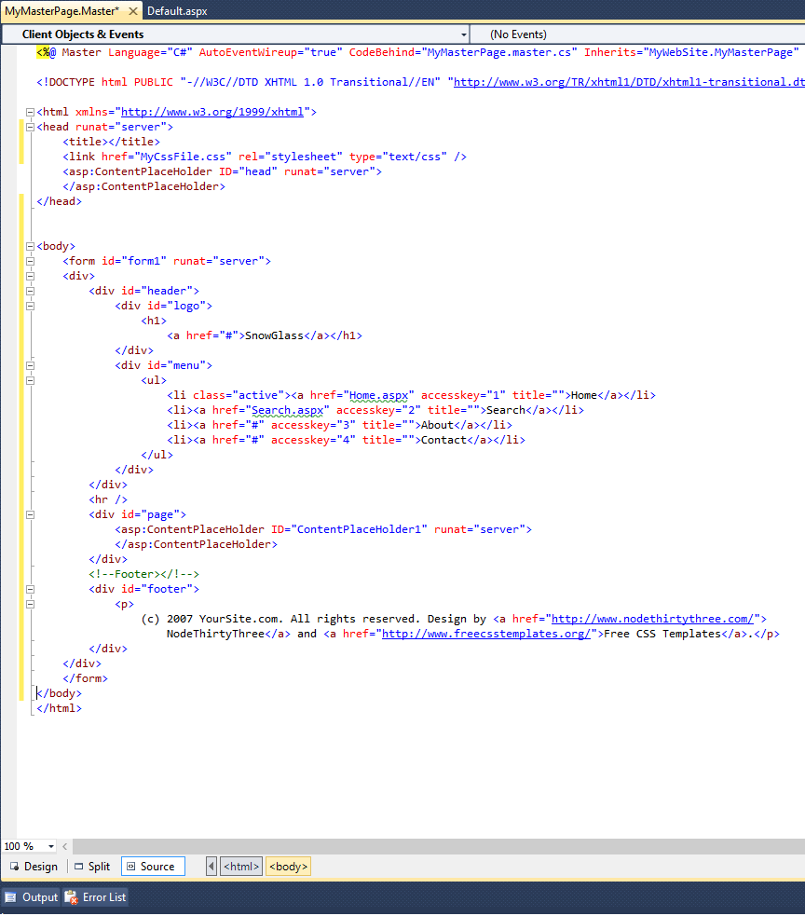

1. Now we create Two Web Forms that will use the Master Pages.

Add New Web Form Using Master Page, Using Add New Item, Name this page as Home.aspx

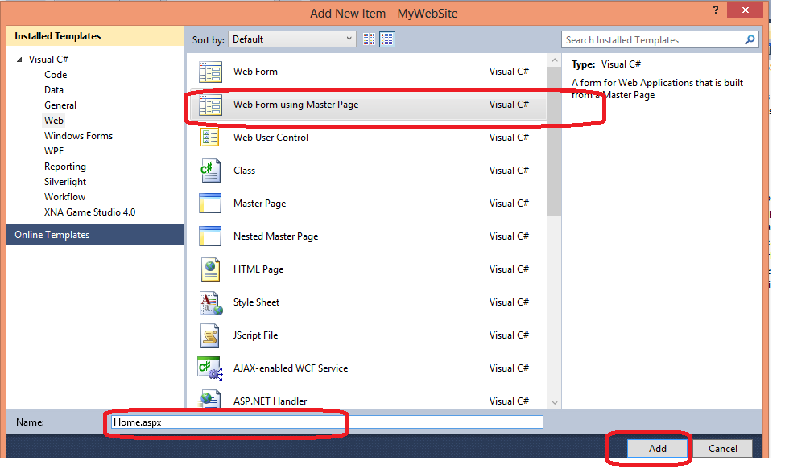

Choose MyMasterPage.Master from Selection Popup

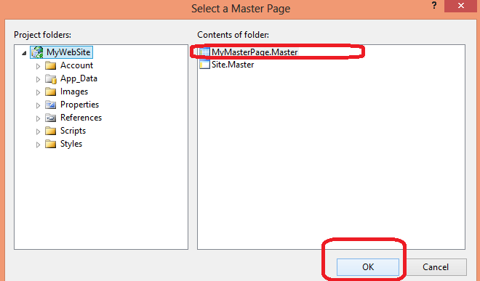

Similarly add another Web Form using Master Page in your Project, Name it ***Search.aspx***

**Confirm the Web Forms are added form solution Explorer**

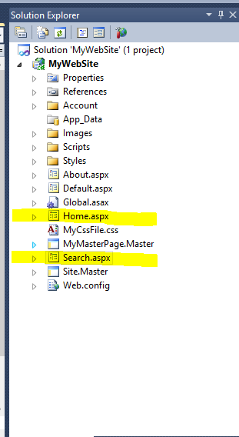

1. Execute your Project and see the result in Browser, Click on home and search and see the change in Address bar (Execute Project by keeping in Home or Search Page)

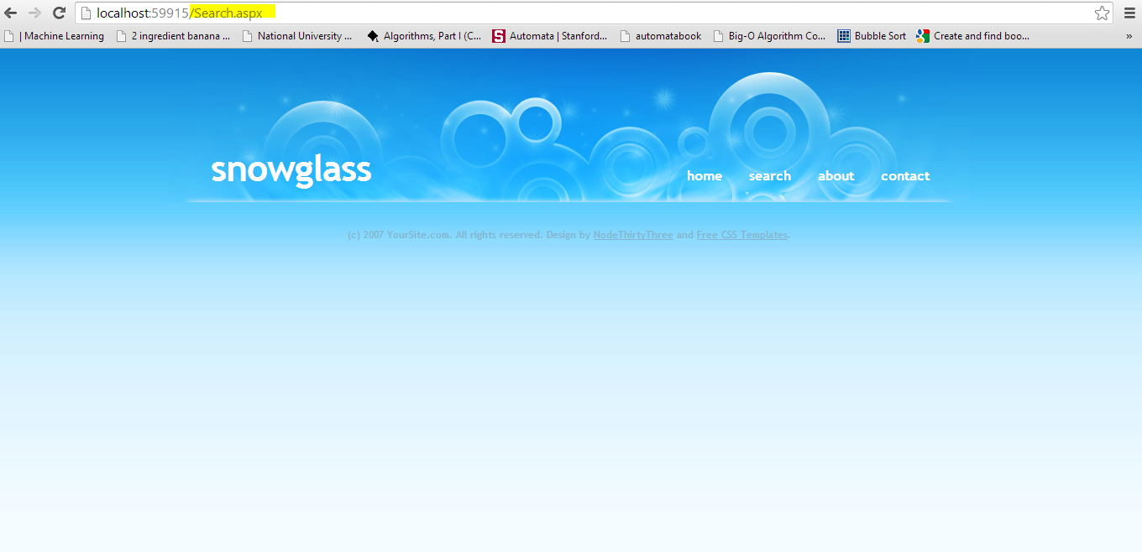

You have successfully created a Master Page and used it in Home Page and Search Pages. Save you work for the next exercise

## Connect with database

The Next Exercise will show how to connect the web site with the SQL databases, and how to Access the Data

1. First Open TheDataBaseQueries.Script file in resources, and execute it in SQL server, this will create a New data base with name F2020Lab11

, an Items Table , and SearchItems Procedure , we will use the data from this table and result from this procedure in our Web site

1. Use the Same Web Project in previous Exercise , Create a DataBase Conection String in Web Config File

FORMAT OF CONNECTION STRING

<connectionStrings>

<add name="SQLDbConnection"

connectionString="Data Source=SQlServerName; Initial Catalog=YouDatabaseName; User Id=userid; password= password"

providerName="System.Data.SqlClient" />

</connectionStrings>

More info about connection string  
<http://msdn.microsoft.com/en-us/library/jj653752%28v=vs.110%29.aspx>

* Data Source means server name i.e. cactus, (local)
* Initial Catalog means database name which has your table, sp and views
* User Id means login name for database
* password means password for database

An Easy Way to get these values are from SQL server Connect to Server Window as Shown in Figure

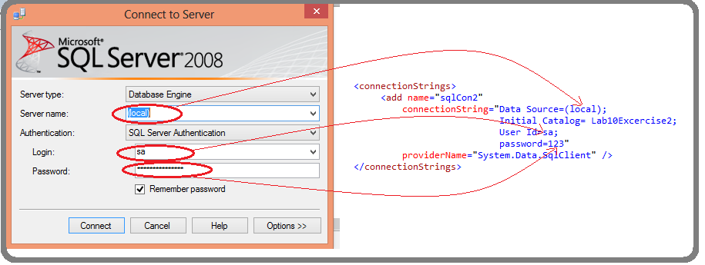

**Sample connection strings**

* **Connection string with window authentication for local host**

<connectionStrings>

<add name="sqlCon1"connectionString="Data Source=(local);Initial Catalog=F2020Lab11;Integrated Security=True"

providerName="System.Data.SqlClient" />  
</connectionStrings>

* **Connection string with SQL server authentication for server name MYSQLSERVER**

<connectionStrings>

<add name="sqlCon1"connectionString="Data Source=(local);Initial Catalog=Lab10Exercise2;User ID=sa;password=123"

providerName="System.Data.SqlClient" />

</connectionStrings>

Add your Connection String in Web Config file as shown in figure

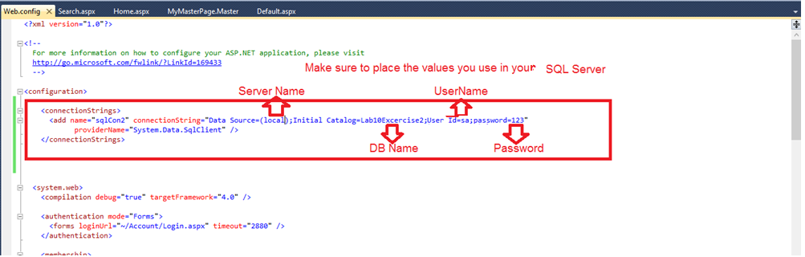

1. Creating DAL --- Data Access Layer, to get Data from SQL

Create New Folder in your Project Named DAL, in this folder Add New Item of type Class and Name it myDAL

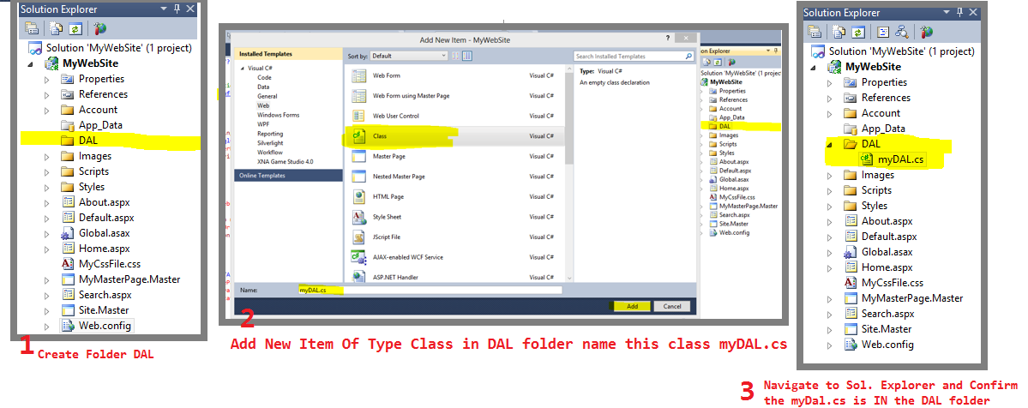

1. open the myDal.cs file and Add the Reference to Connection String plus , Name Spaces for SQL and DataSets

private static readonly string connString =

System.Configuration.ConfigurationManager.ConnectionStrings["sqlCon1"].ConnectionString;

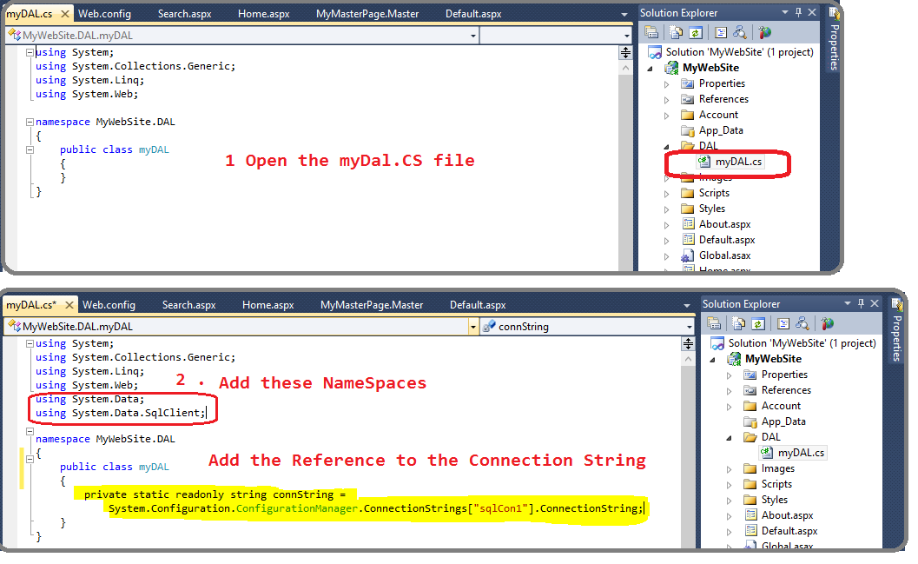

1. Now Create the a function in myDal Class that will perform a simple *select * from Item* query on Database and get the result set

Copy paste the function **SelectItem()** from Function_SelectItems.Txt file

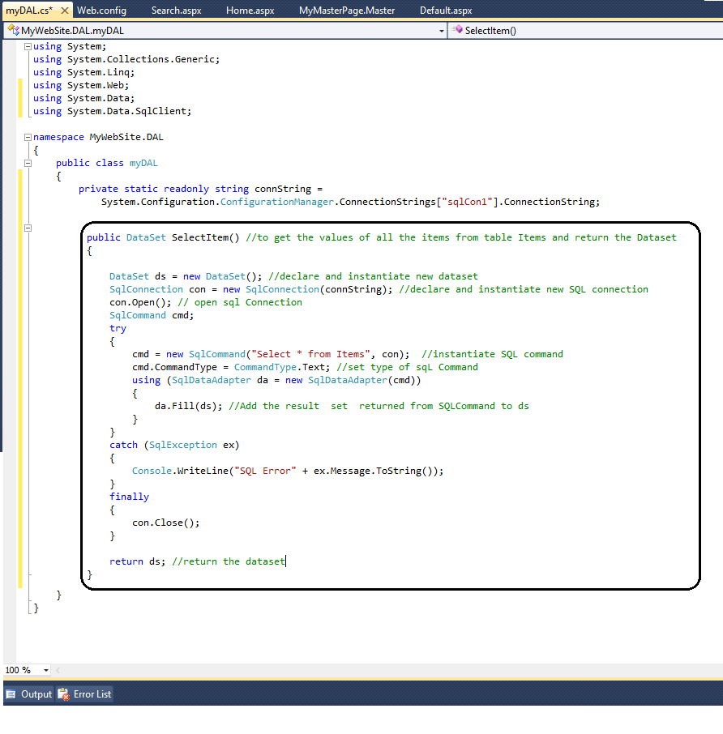

1. Using SelectItems() function to Displaying the result set

Now we display the DataSet returned from SelectItem() on Home page

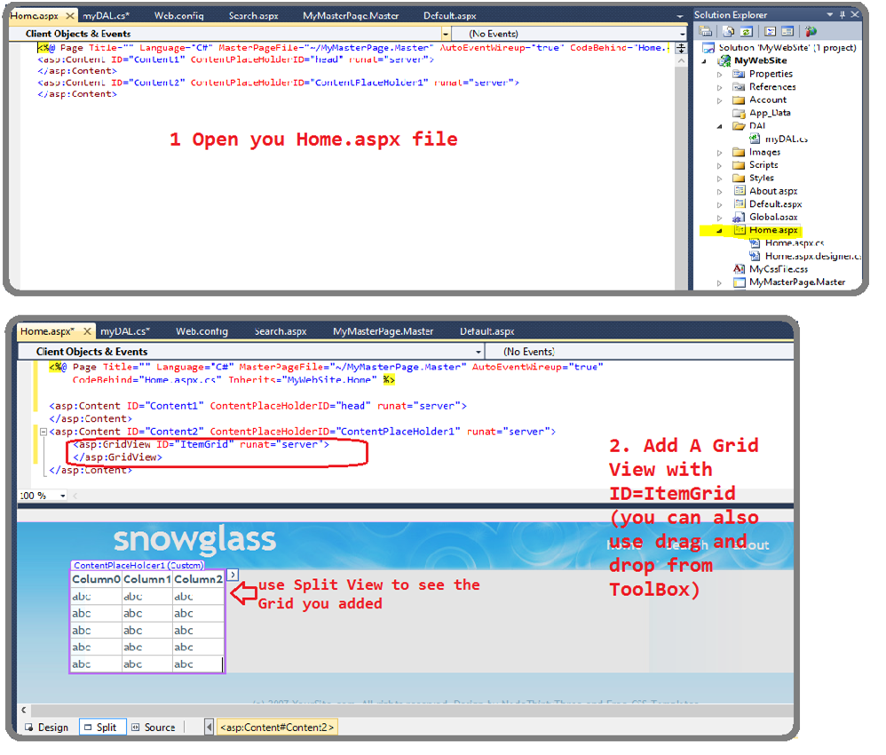

You can see that the Grid Already look like a table , all you need to do is fill the values in it from your Query

The contents of Grid are changes from Server Side Aspx.csfile, open your [Home.aspx.cs](http://Home.aspx.cs) file , modify it (changes are given In Home_aspx_CS.txt file)

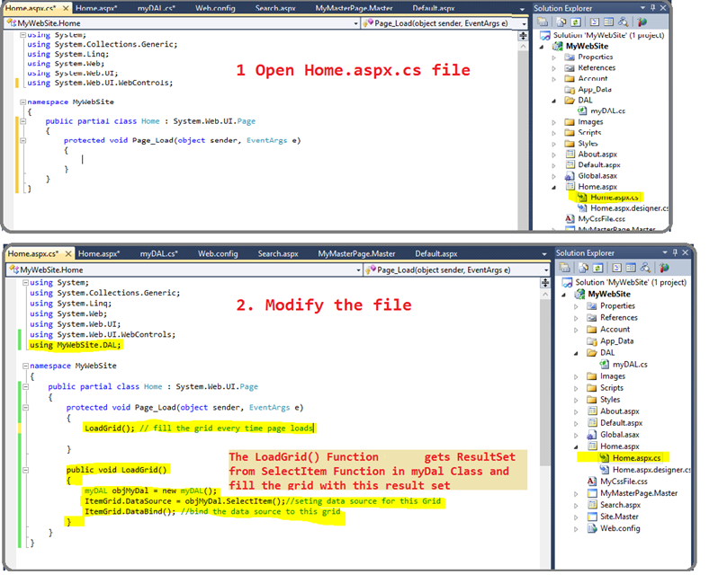

Execute your Project, and if everything goes right, the Home page should be as follows:

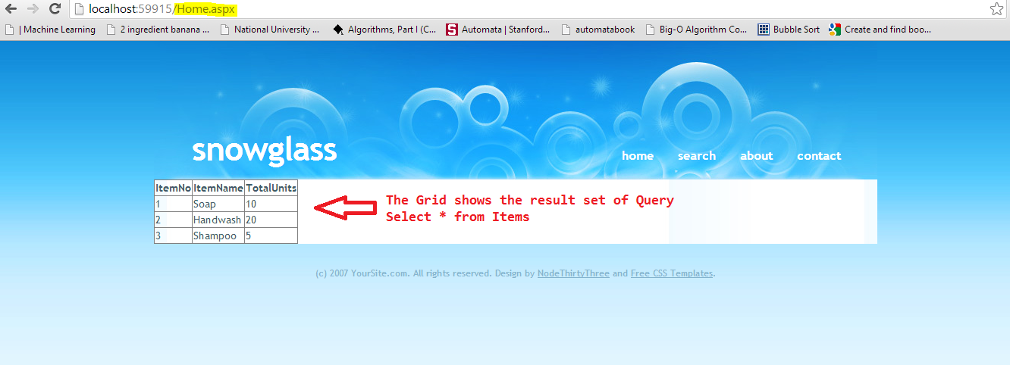

You have successfully used The Result of a simple Query on your Website!

## Using SQL procedures in Asp.Net

So far we have used a Table form result set of a simple query and displayed on our web site, the following Exercise will show how to call SQL procedures from ASP.net, how to pass them input parameters and how to get output parameters and result sets from SQL procedures

We have already create a Web Form Names **Search.aspx** in our Web Project and **SearchItem** SQL procedure (in database), Now we will add search Functionality on our page, by getting the Item Name from user and querying the database for that item using **SearchItemsqL** Procedure, the procedure will return the dataset and output found =1 if any item with that name exists, and if no item is found for that Item it will output Found = 0.

**Open Search.aspx page and modify the Code, (Adding Text box and Button and a Grid to show the result of search)**

Code given in file Search_Aspx.txt

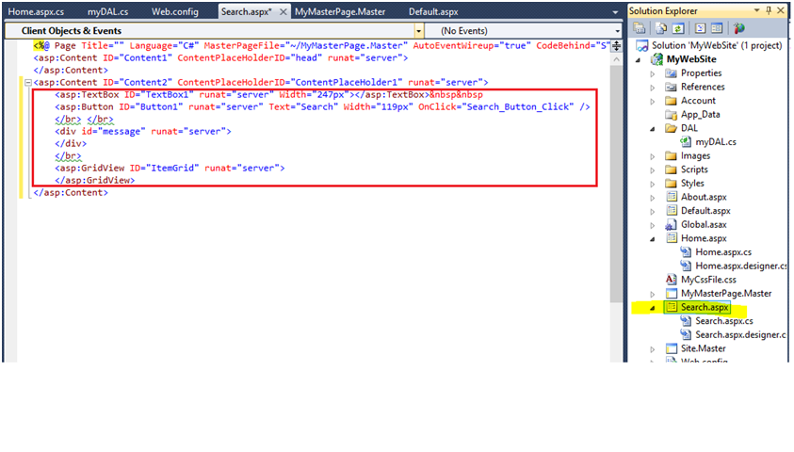

Open myDal.cs file and Add SearchItems() function in it (code given in Function_Searchitems.Txt file) as shown in figure

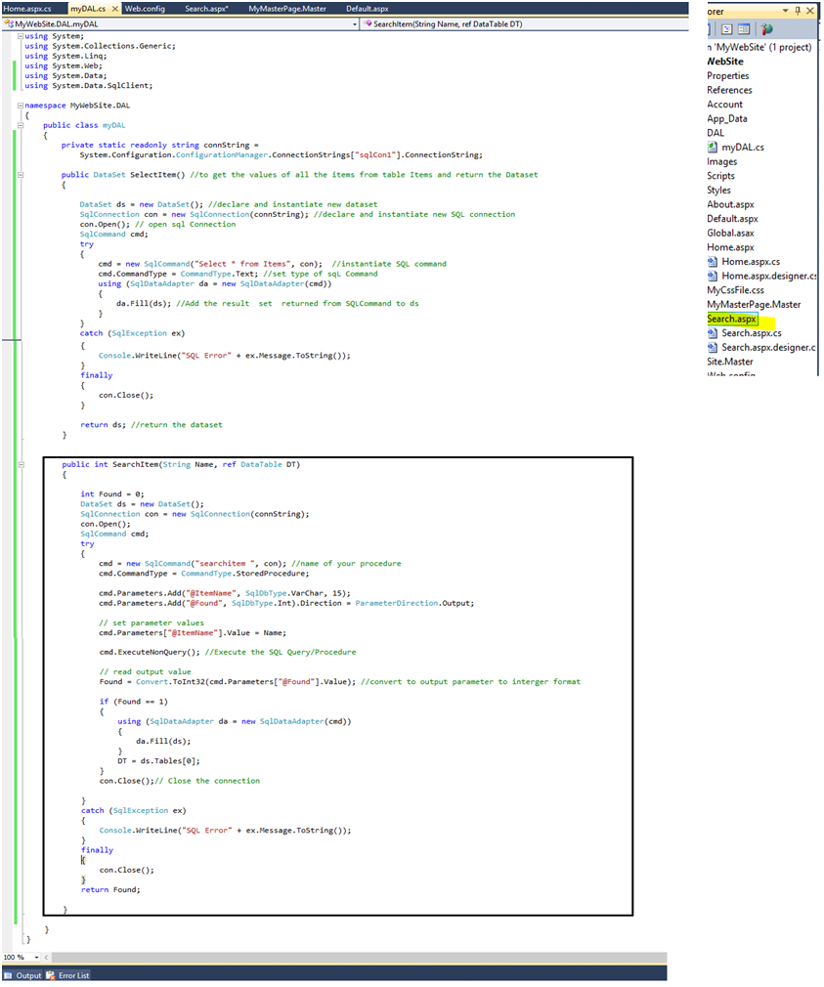

Use this new Function SearchItem() in Server Side Search.aspx.cs

Open Search.aspx.cs file and modify it as shown in figure (code given in Search_Aspx_CS.txt file)

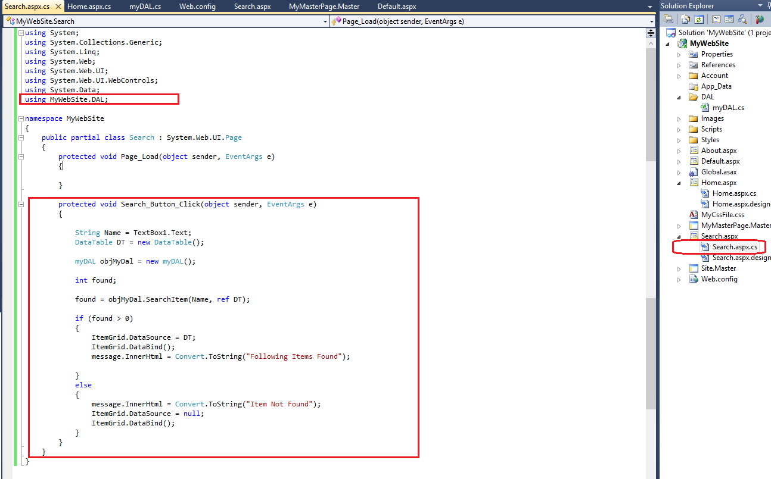

Execute your project,Type Soap in Text box and Click Search, following results should appear

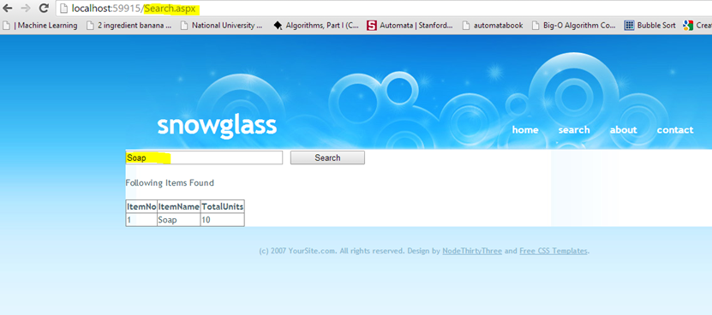

Now Type some random string in Test box and Click Search, Following Results Should Appear

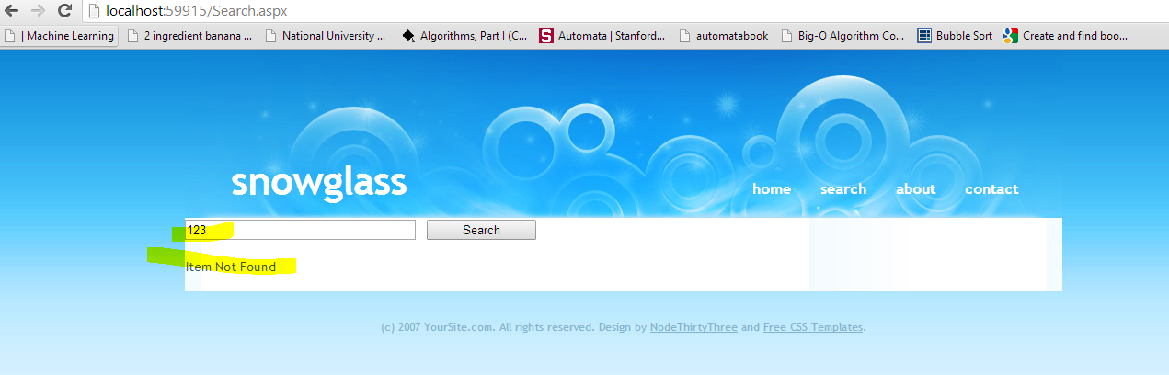

**Post lab**

Make another webpage with search bar in it. It displays only the item with quantity greater than 5 otherwise it should display ‘Out of stock’.